SECTION 07 68 13 ROOF DECKING PEDESTALS

PART 1 GENERAL

  - SUMMARY
Specifier Note: Retain or delete material(s) below to conform to project requirements.

    - Section Includes:

      - Roof decking pedestals as shown on Drawings and specified herein. Include related attachments, and accessories.

    - Related Sections:

      - Section 07 76 16 “Roof Decking Pavers” for pedestal mounted roof pavers.

Specifier Note: Article below may be omitted when specifying manufacturer’s proprietary products and recommended installation. Retain Reference Article when specifying products and installation by an industry reference standard. If retained, list standard(s) referenced in this section. Conditions of the Contract or Section 01 42 19 - Reference Standards may establish the edition date of standards. This article does not require compliance with standard, but is merely a listing of references used. Article below should list only those industry standards referenced in this section.

  - REFERENCES

    - ASTM E 108/UL 790 – Standard Test Methods for Fire Tests of Roof Coverings

Specifier Note: Article/Paragraphs below includes submittal of relevant data to be furnished by Contractor, either before, during or after construction. Coordinate Article/Paragraphs with Architects and Contractors duties and responsibilities in Conditions of the Contract and Section.

  - SUBMITTALS

    - Comply with Section 01 33 00.

    - Shop Drawings: Submit plan layout of all paver areas and detail drawings showing how the various components of the roof pedestal system fit together.

    - Product Data: Manufacturer’s literature completely describing all components of the paver pedestal systems, including:

      - Preparation instructions and recommendations.

      - Installation methods and application procedures.

    - Samples for Verification:

      - Submit sample of each pedestal component for each type of pedestal system.

    - Test Reports for the following requirements:

      - Structural Analysis: Provide test report indicating the structural capability and adequacy of the roof decking pedestal assembly to carry the dead and live loads imposed by the roof decking.

      - Laboratory Test Reports: Exterior fire-test exposure reports performed by independent testing agency indicating that roof decking pedestals comply with specified fire resistance classification.

    - Certification:

      - Manufacturer and Installer Qualifications.

  - LEED
Specifier Note: SUSTAINABILITY: LEED: Use the following paragraphs when LEED Submittals are required.

    - LEED Submittals: In accordance with [LEED] [and] [Section 01 35 21LEED Requirements] [ ].

      - Submit required letters, calculations, spreadsheets and templates prepared by [Engineer] [Consultant] [Architect] [ ] for submitting to USGBC for Credit Interpretation Requests.

      - Submit Project Materials and Cost Data: Provide statement for total cost for building materials used for Project.
Specifier Note: SUSTAINABILITY: LEED 2009 (first option below) and LEED v.4 (second option below).

      - Materials and Resources Credit: [MRc.4 Recycled Content][MRc Building Product Disclosure and Optimization – Sourcing of Raw Materials]: Submit product data [and certification letter(s)] of proposed materials with recycled content:

        - Showing their cost and percentages by weight of post-consumer and pre-consumer recycled content.
Specifier Note: Article below should include prerequisites, standards, limitations and criteria, which establish an overall level of quality for products and workmanship for this section. Coordinate article below with Division 01 Quality Assurance Section.

  - QUALITY ASSURANCE

    - Comply with Section 01 40 00.

    - Manufacturer: Company specializing in manufacturing Work of this Section with minimum 25 years documented experience.

    - Installer: Company specializing in performing Work of this Section with minimum 5 years documented experience.

    - Single Source Responsibility: Obtain each type of roof decking pedestals from single manufacturer.

Specifier Note: Include a mock-up, if the project size and/or complexity of the work require installation to be approved by Architect.

    - Mock Up: Provide a mock-up for evaluation of surface preparation, installation techniques and quality of application.

      - Size and extents as indicated on Drawings, or designated by Architect.

      - Do not proceed with remaining work until installation is approved by Architect.

  - DELIVERY, STORAGE, AND HANDLING

    - Comply with Section 01 60 00.

    - Accept delivery of materials only in unopened and undamaged containers bearing the brand name and manufacturer’s identification. Protect from damage until ready for installation.

    - Immediately remove damaged or otherwise unsuitable materials, when so determined, from Project site.

  - PROJECT CONDITIONS

    - Surfaces to receive roof decking pedestals shall be broom clean, frost free, and free of dirt, oil or any rough foreign matter, which may impair the proper installation of the roof decking pedestals.

    - Confirm that substrates have positive slope and provide adequate drainage in accordance with applicable building codes.

    - Do not install roof decking pedestals over any roofing insulation with a density of less than 414 kPa (60 psi).

Specifier Note: Coordinate article below with Conditions of the Contract and with Section 01 78 36 - Warranties.

  - WARRANTY

    - Manufacturer’s Warranty: Pedestal system shall remain free from manufacturing defects for a period of ten (10) years from date of Substantial Completion.

    - Contractor’s Warranty: Contractor shall warrant that their work will remain free from defects of labor and materials for a period of [two] [ ] years from date of Substantial Completion.

PART 2 PRODUCTS

  - MANUFACTURER

    - Acceptable Manufacturer: Buzon Pedestal International, which is located at:

- Buzon Pedestal International SA: Z.I. des Hauts-Sarts, Zone I Prolongement de la rue l’Abbaye, 134, B-4040 Herstal, Belgium; Contact: Laurant Buzon; Tel: +32-4-248 39 83; Fax: +32-4-264 82 38; Web: www.buzon-world.com

- Buzon USA West: Contact: Erik Nelson; Tel: 503-954-3336; Fax: 866-521-0440; Email: sales@buzonusawest.com; Web: www.buzonpedestals.com

- Buzon USA East:16 W. 56th St.; New York, NY 10019; Contact: Mufdi Siraji; Tel: 646-929-4318; Fax: 212-243-2868; Email: ms@buzonusaeast.com; Web: www.buzonusa.us

- BUZON CANADA 8151 Boul. Montreal-Toronto, suite 102 - H4X 1N1 Montreal-Ouest, Quebec; Contact J.Raposo Tel : +514 38 10 098 ;Fax : +514 38 16 496 E-MAIL : j.raposo@buzoncanada.ca Web: www.buzoncanada.ca

Specifier Note: Delete one of the following two paragraphs.

    - Substitutions: Not permitted.

    - Requests for substitutions will be considered in accordance with provisions of Section 01 25 00.

  - PERFORMANCE REQUIREMENTS

    - Exterior Fire-Test Exposure: Provide roof decking pedestal system listed as Class A fire resistance rating when tested in accordance with ASTM E 108 or UL 790 by an independent testing agency acceptable to authorities having jurisdiction. Identify products with appropriate markings of applicable testing agency.

    - Compression Resistance: Roof decking pedestal system shall be capable of withstanding maximal breaking loads up to 1000kg (2204 lbs.).

    - Recycled Content: Pedestal system shall contain 80% post-industrial recycled content and be 100% recyclable.

  - SCREWJACK PEDESTAL SYSTEM

    - Screwjack Pedestal System:

      - Basis of Design: PB-Series as manufactured by Buzon Pedestal International.

    - Fix / Adjustable Height Pedestal: Suitable for all types of roof decks and terraces using precast concrete pavers and other heavy materials.

      - Composition: Four piece, interlocking, multi-threaded unit consisting of mounting head, height extension coupler, support base, and slope corrector.

        - Head Support: Screwed directly into the support base or height extension coupler, and fitted with slots to receive circular or rectangular tabs of various thicknesses that achieve an open gap between pavers.

        - Height Extension Coupler: One-piece extension coupler with upper part threaded to receive additional extension couplers or the pedestal head, and lower part threaded to screw into the support base. Including safety clips to prevent total unscrewing of the pedestal head or ring clamp. Lock keys keep the pedestal height in place after height adjustment.

        - Support Base: Cylindrical support base with reinforcement ribs and fitted with clamps to receive the pedestal. Placed or fixed to a solid substrate, base can be cut away for positioning against a wall. Includes holes at bottom for drainage.

        - Slope Corrector: Placed at the underside of the support base and formed from two cylindrical parts that allows compensating for 1 to 5% slopes and providing a level mounting head; 255mm (10 inch) diameter; 12mm (1/2 inch) thickness to be added to the adjustable height of the pedestal.

        - Shim: Cylindrical support base to increase of 4 mm (5/32 inch) the thicknessto be added to the height of the pedestal . Includes holes at bottom for drainage. Possibility to stack more than one.

      - Height Range: Fix (15 mm; 5/8 inch) or infinitely adjustable by rotation of the mounting head device, using variable height support bases, and multiple height extension couplers ranging from 28 to 965 mm (from 1-3/32 inch to 38 inches).
      - Materiel: Ultraviolet (UV) stabilized, talc-filled, high density, copolymer polypropylene, weather, sea salt, and chemical resistant; 3 to 4.5mm (1/8 to 3/16 inch) wall thickness.

      - Temperature Range: Resistant from -30º C to 90º C (-22º F to 194º F).

    - Mounting Head Accessories: Spacer tabs, support pins, and joist supports that can be clipped to the head of the pedestal to accommodate the selected roof decking material.

  - PERIMETER CONTAINMENT AND SUPPORT

    - The complete assembly of roof decking pedestals and pavers shall be restrained at the perimeter of the walk deck area to resist lateral movement. Cumulative movement in excess of 3mm (1/8 inch) will void the manufacturer’s warranty.

PART 3 EXECUTION
Specifier Note: Paragraph below is an addition to CSI SectionFormat. Retain or delete paragraph(s) below to conform to project requirements.

  - EXAMINATION

    - Examine areas and conditions under which Work of this Section will be performed. Notify Architect of unsatisfactory preparation before proceeding.

    - Correct conditions detrimental to timely and proper completion of Work.

    - Do not proceed until unsatisfactory conditions are corrected.

    - Verify elevations and roof decking dimensions before commencing work.

    - Lay out work prior to the commencement of installation.

    - Beginning of installation means installer accepts existing conditions.

  - INSTALLATION

    - Install roof decking pedestals in accordance with manufacturer’s recommendations. Securely place base supports at locations shown on shop drawings.

    - Locate pedestals at the proper elevation and placed in position prior to the installation of roof decking pavers.

    - Level Installation: Establish starting point and finished elevation of the roof decking paver surface, and determine the pedestal head support elevation by subtracting the thickness of the paver. Mark around the perimeter using transit, or laser leveling device.

    - Slope Compensation: Place slope correctors under the pedestal base to compensate for slope in the substrate. Compensate for slope by rotating the device and locking as per manufacturer’s recommendations to create a level and plumb paver surface over sloping substrates.

    - Perimeter Containment: Provide field installed restraint, where roof decking is not constrained by an abutting wall. No movement shall be allowed at the perimeter of the roof decking greater than 3mm (1/8 inch).

    - Make final slight adjustments to pedestals as they are fully loaded by roof decking pavers.
    - Level each succeeding row of pedestals as the roof decking paver installation proceeds.

  - TOUCH-UP AND PROTECTION

    - Replace damaged roof decking pedestals before Substantial Completion.

    - Protect installed roof decking pedestals until completion of project.

  - FIELD QUALITY CONTROL

    - Ensure roof decking pedestals are maintained in a straight and consistent pattern and that installed deck pavers are level and do not rock back-and-forth under loading.

    - At roof deck access points for pedestrians, ensure that pavers are level and that the walking surface does not have randomly raised or uneven joints creating a tripping or safety hazard.

END OF SECTION

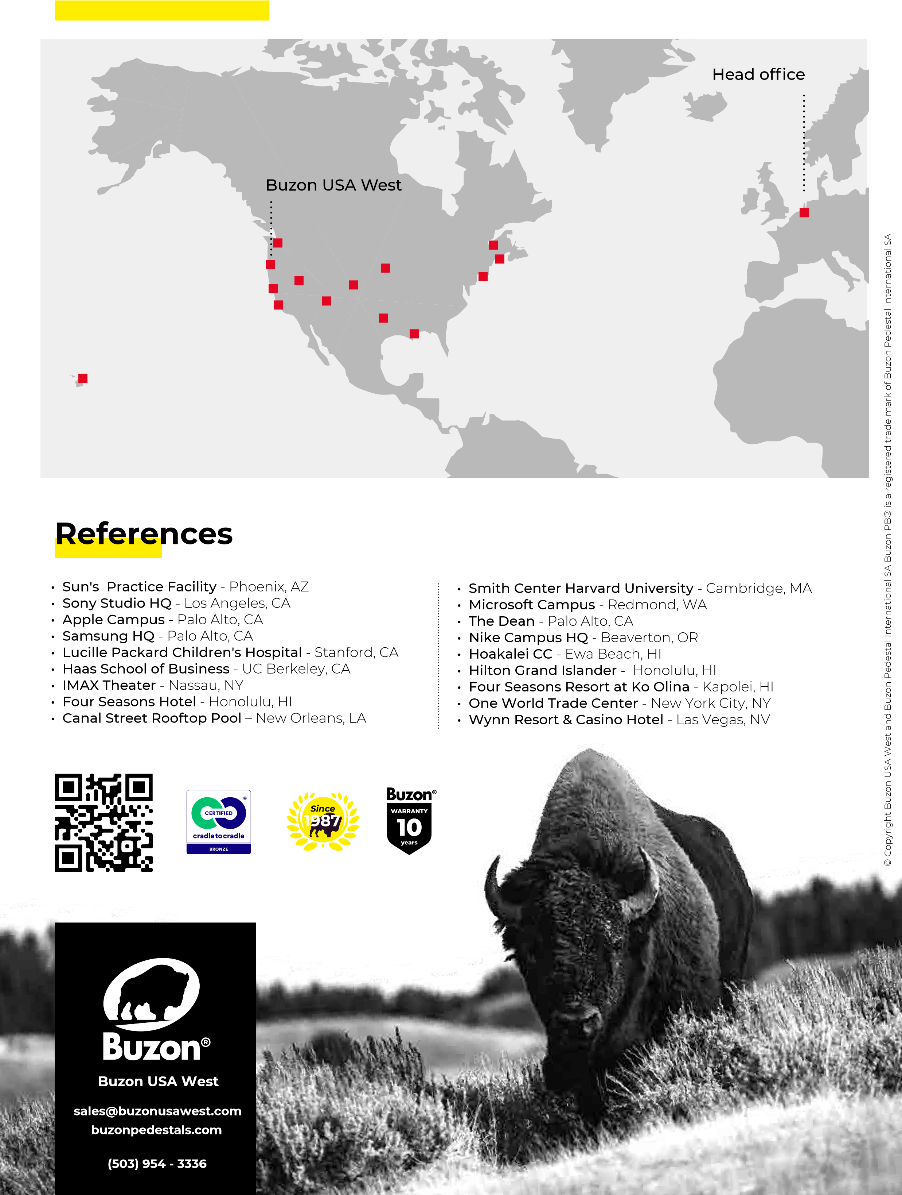
Buzon USA West Projects

